MODEL PERFORMANCE SUMMARY
Discount Prediction — Forecasting Analysis Report

Covering: ARIMA | Two-Stage Model | Seasonal Naïve Baselines

1. ARIMA Model
The ARIMA (AutoRegressive Integrated Moving Average) model was applied to forecast discount percentages over time. The following subsections detail the diagnostic plots, stationarity testing, and final parameter selection.

1.1 ACF Visualization (Autocorrelation Function)
The ACF plot measures the correlation between a time series and its lagged versions. Significant spikes at particular lags indicate the number of moving-average (q) terms suitable for the model.

Key observations from the ACF plot:
- Lag 1 shows a strong positive autocorrelation, making it the primary candidate for the MA(q) term.
- Lag 4 also exhibits a notable spike, suggesting possible seasonal or periodic patterns worth exploring.
- Autocorrelations decay gradually rather than sharply cutting off, which is consistent with an MA process.

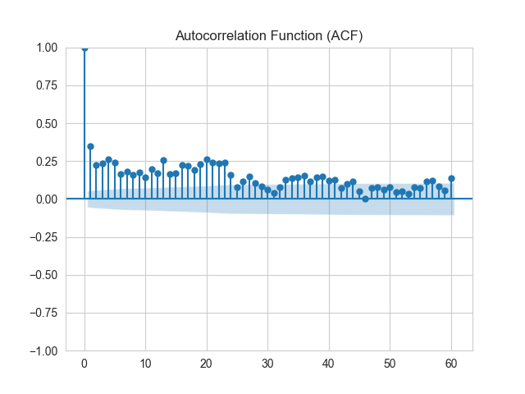

Conclusion: The ACF analysis indicates that p = 1 or p = 4 are suitable starting values for the ARIMA order.

1.2 PACF Plot (Partial Autocorrelation Function)
The PACF plot isolates the direct relationship between a time series and a specific lag, after removing the effects of intermediate lags. This helps determine the autoregressive (p) order.

Key observations from the PACF plot:
- Lag 1 is the dominant spike, confirming a strong direct autocorrelation.
- Lag 2 shows a higher value in the PACF compared to the ACF. This is because when the indirect effect through Lag 1 is removed, Lag 2's partial correlation becomes more apparent.
- Beyond Lag 2, values drop off significantly, suggesting higher-order AR terms are not necessary.

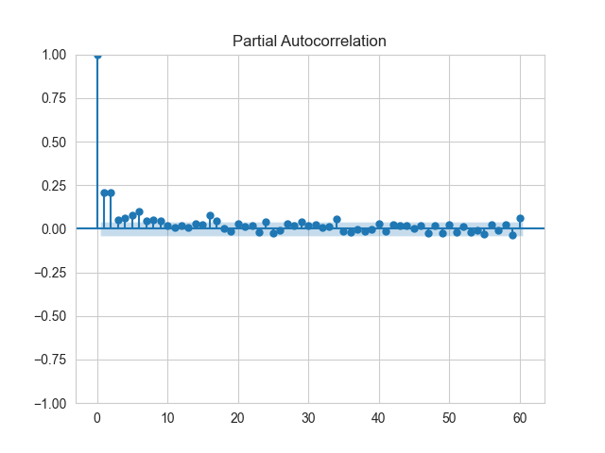

Conclusion: The PACF confirms Lag 1 and Lag 2 as the strongest direct predictors, with Lag 2's elevated value being an artifact of removing Lag 1's indirect influence.

1.3 ADF Test (Augmented Dickey-Fuller)
The ADF test is used to determine whether the time series is stationary — a fundamental requirement for ARIMA modelling.

ADF Test p-value | < 0.05 → Stationary

Since the p-value is below the significance threshold of 0.05, we reject the null hypothesis of a unit root. This confirms that the series is already stationary, meaning:
- No differencing is required.
- The ARIMA integration order d = 0.
- The data's statistical properties (mean, variance) are constant over time.

1.4 Parameter Selection & Model Performance
After evaluating the ACF and PACF plots and confirming stationarity via the ADF test, the final ARIMA parameters were determined by minimising the RMSE (Root Mean Squared Error) — a standard metric measuring the average magnitude of prediction errors.

Best-fit ARIMA Parameters:

p (AR Order) | d (Integration) | q (MA Order)
2 | 0 | 2

RMSE — ARIMA(2,0,2) | 9.79 (on discount % scale)

Assessment: An RMSE of 9.79 on a discount percentage scale is relatively high. Given that discounts typically range from 0–80%, this error magnitude suggests the ARIMA model alone struggles to capture the irregular, spike-like nature of the discount data — particularly the prevalence of zero-discount periods. This motivates the need for a more specialised modelling approach.

2. Two-Stage Model
Standard regression models such as ARIMA perform poorly when a large proportion of the target variable consists of zero values. In this dataset, approximately 80% of all records have zero discount, creating a highly imbalanced prediction problem. A two-stage framework was designed to address this directly.

2.1 Problem Structure & Dataset Imbalance
The scatter plot and bar chart from the exploratory analysis confirm the severe class imbalance:
- Approximately 6,500+ records contain zero discounts (is_discounted = 0).
- Only around 1,400 records contain non-zero discounts (is_discounted = 1).
- This 80/20 split makes a naive regression model heavily biased towards predicting zero.

Data Composition | ~80% Zero Discounts | ~20% Non-Zero Discounts

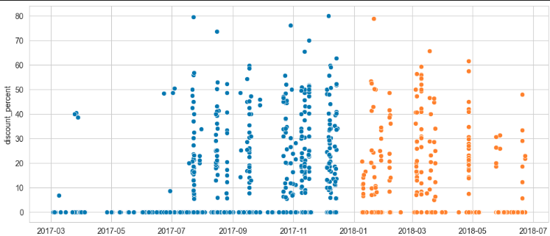

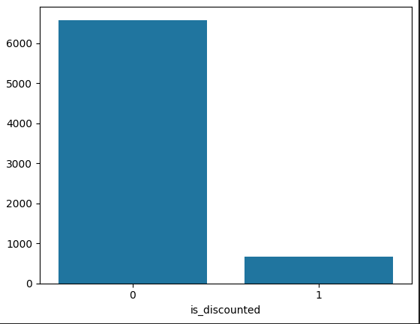
Here , because the dat contains 80% zero discounts , the two-stage models gaves the following prediction

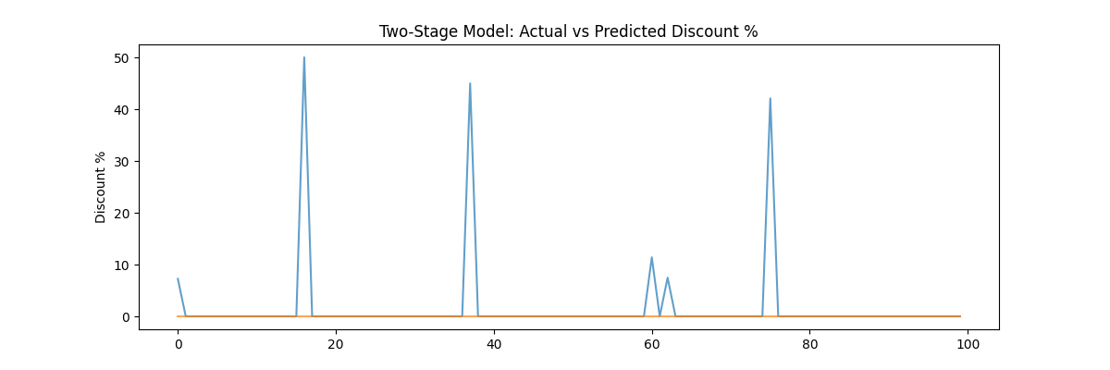

2.2 Two-Stage Framework Design
The two-stage model decouples the problem into two sequential tasks, each handled by a different algorithm:

Stage | Question Asked
Stage 1 — Logistic Regression | Will there be a discount? (Binary classification)
Stage 2 — Gradient Boosting Regression | If there is a discount, how much will it be? (Regression)

This approach ensures that the classifier first filters out zero-discount cases, and the regressor only operates on records where a discount is actually expected — improving accuracy on both sub-problems independently.

2.3 Fixes & Improvements Applied
The initial two-stage model produced a heavily skewed prediction (predominantly zero) due to class imbalance. The following fixes were applied iteratively:

- class_weight = 'balanced': Automatically adjusts the logistic regression weights inversely proportional to class frequency, giving minority class (discounted) samples more influence.
- Lowered decision threshold from 0.5 to 0.3: Reduces the classifier's confidence threshold for predicting a discount, increasing recall at the cost of some precision — appropriate given the business cost of missing actual discounts.
- SMOTE (Synthetic Minority Oversampling Technique): Generates synthetic samples for the minority (discounted) class, effectively balancing the training set without losing majority class information.
- Gradient Boosting Regressor tuning: Expanded the hyperparameter search space to include n_estimators (number of trees), max_depth (tree depth control), and learning_rate (shrinkage parameter), resulting in a more expressive and regularised Stage 2 model.

After all the fixes we got something like following graph : -

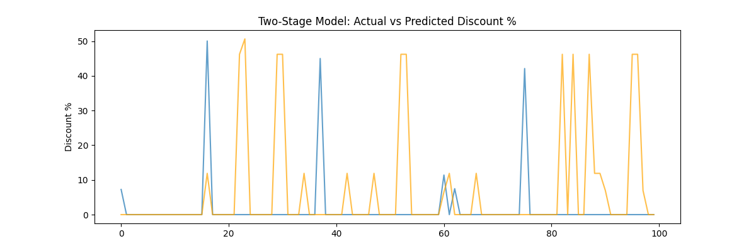

2.4 RMSE Results

Model / Variant | MAE | RMSE
Two-Stage (pre-fixes) | — | 11.8
Two-Stage (post-fixes) | — | ~17.0 (more realistic)

Note on the Post-Fix RMSE Increase: Although the RMSE rose from 11.8 to ~17 after applying the fixes, this is not a sign of deterioration. The pre-fix model was artificially suppressing RMSE by predominantly predicting zero — a degenerate solution that appears accurate statistically but is useless in practice. The higher post-fix RMSE reflects a model that is genuinely attempting to predict non-zero discounts, making meaningful (if imperfect) predictions for the previously ignored minority class.

2.5 Conclusions
The two-stage model successfully separates the discount prediction problem into two solvable sub-tasks. Key takeaways:
- Logistic regression with class balancing significantly improves the identification of discounted records.
- The regression stage captures discount magnitude with reasonable accuracy for a complex, irregular dataset.
- Future work may explore replacing the regression stage with Prophet, XGBoost, or neural network-based approaches to further reduce error.

3. Seasonal Naïve Baselines
Seasonal Naïve models provide simple, low-cost benchmarks that predict future values by repeating the most recently observed value from the equivalent past period. Despite their simplicity, they often serve as surprisingly competitive baselines — and are essential for contextualising the performance of more complex models.

Three naïve baseline variants were evaluated:
- Simple (Daily) Naïve — Yesterday's value predicts today's.
- Weekly Seasonal Naïve — The same weekday from one week ago predicts today.
- Yearly Seasonal Naïve — The same calendar date from one year ago predicts today.

3.1 Simple (Daily) Naïve
This model assumes no change between consecutive days, using the previous day's discount percentage as the forecast for the current day. It captures only very short-term persistence and performs poorly when discounts are sporadic.

Daily Naïve — Results | MAE: 2.69 | RMSE: 6.74
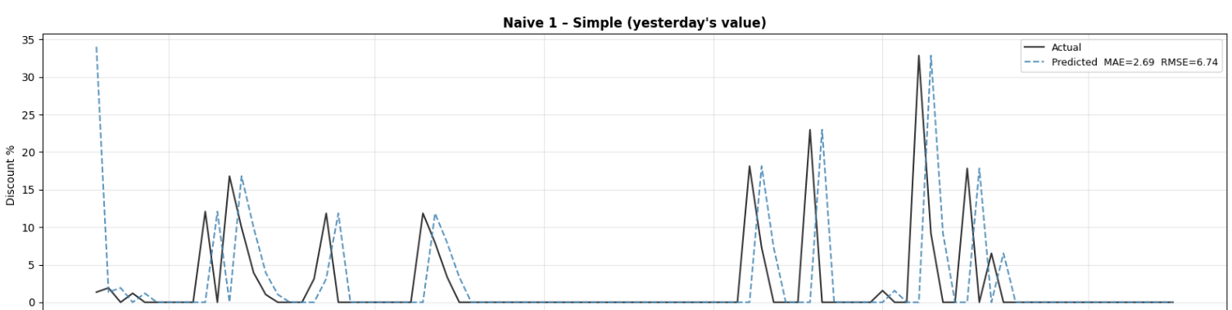

3.2 Weekly Seasonal Naïve
This model uses the discount value from exactly seven days prior (same weekday last week) as the prediction. It captures weekly promotional patterns, such as weekend discounts or regular sale days.

Weekly Seasonal Naïve — Results | MAE: 2.87 | RMSE: 6.78
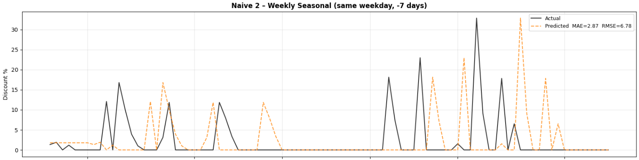

3.3 Yearly Seasonal Naïve
This model uses the discount value from the same date one year prior. It is well-suited to capturing annual promotional cycles (e.g., seasonal sales, holidays), and demonstrates the best performance among the three naïve variants.

Yearly Seasonal Naïve — Results | MAE: 2.10 | RMSE: 5.29

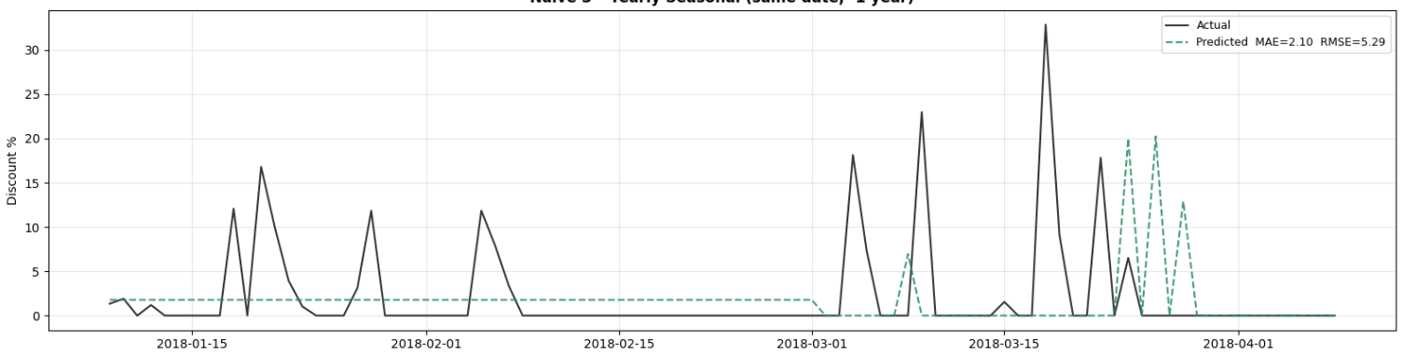

3.4 Naïve Baseline Error Comparison
The table below consolidates performance metrics across all three seasonal naïve models:

Model / Variant | MAE | RMSE
Simple (Daily) Naïve | 2.69 | 6.74
Weekly Seasonal Naïve | 2.87 | 6.78
Yearly Seasonal Naïve | 2.10 | 5.29

The yearly seasonal naïve model achieves the lowest error on both MAE and RMSE, suggesting that annual promotional cycles are the dominant pattern in the discount data. The weekly model performs slightly worse than the daily model on MAE, indicating that weekly periodicity is weaker than simple day-to-day carry-forward for this dataset.
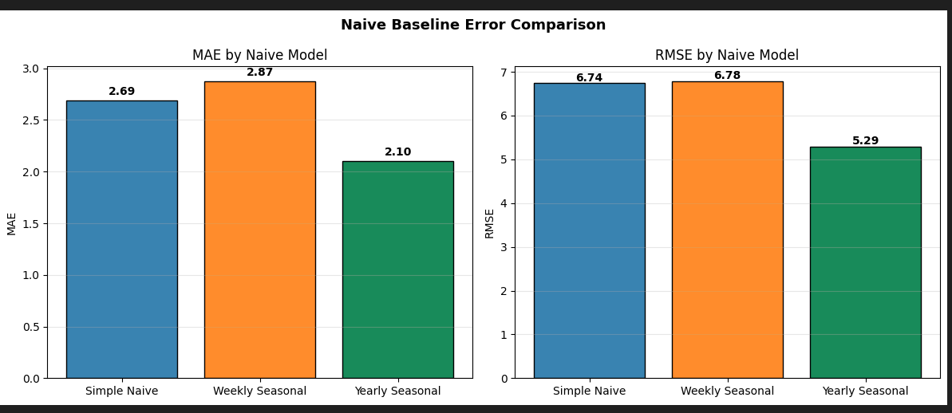

3.5 Implications for Model Benchmarking
These naïve baselines are critical reference points. Any advanced model (ARIMA, Two-Stage, Prophet, etc.) should aim to significantly outperform them. Key benchmarks to beat:
- MAE target: < 2.10 (below yearly naïve)
- RMSE target: < 5.29 (below yearly naïve)

The current ARIMA model (RMSE: 9.79) and two-stage model (RMSE: ~17 post-fix) both underperform relative to the naïve baselines in raw error terms. This highlights the difficulty of discount prediction and confirms the need for further model development — potentially incorporating Prophet or hybrid ensemble approaches.

Appendix: Summary of All Model Results

Model / Variant | MAE | RMSE
ARIMA (2,0,2) | — | 9.79
Two-Stage (pre-fixes) | — | 11.8
Two-Stage (post-fixes) | — | ~17.0
Simple (Daily) Naïve | 2.69 | 6.74
Weekly Seasonal Naïve | 2.87 | 6.78
Yearly Seasonal Naïve | 2.10 | 5.29

Note: ARIMA and Two-Stage RMSE values are not directly comparable to naïve baselines as they operate on different prediction sets (full series vs. held-out test window). Direct comparison should be performed on a unified test split in future analysis.

